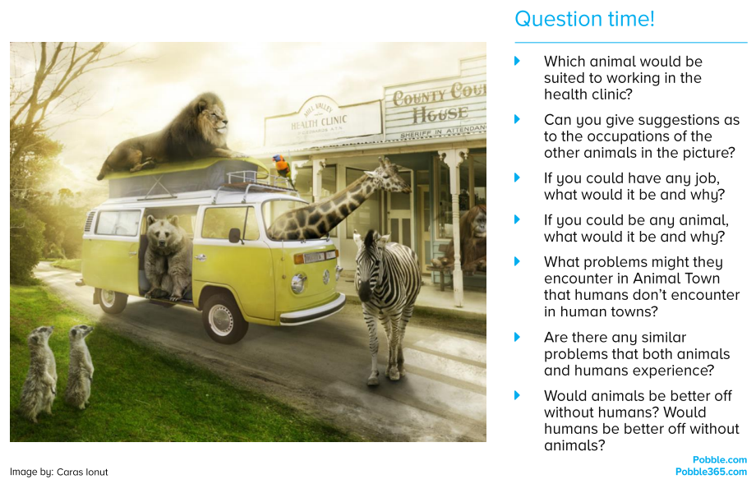
Literacy session 6: Animal Town

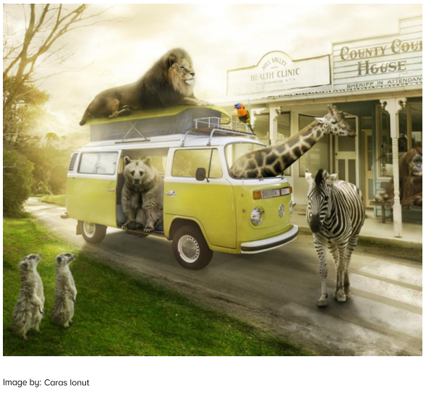
Can you write some sentences using verbs (doing words) and adverbs (adding –ly to describe the verb) to describe what the animals are doing?

For example:
The zebra walked slowly across the road.

The parrot squawked noisily on the roof rack.

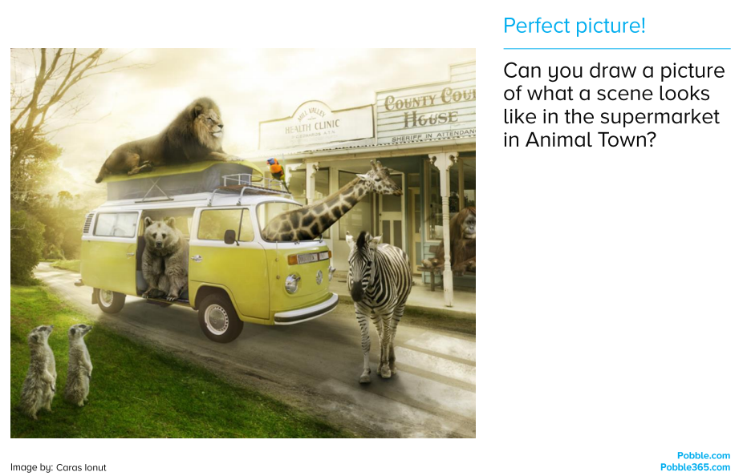
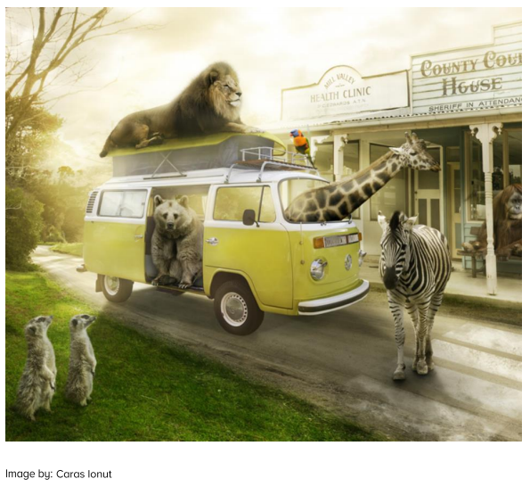
Choose an animal from the picture to create a non-chronological report about.
Split your report into sections:
- Introduction
- Appearance
- Diet
- Habitat
- Behaviour
- Fascinating facts
Challenge: Can you include some questions and exclamations?

