Literacy session 5: Magic Biscuits
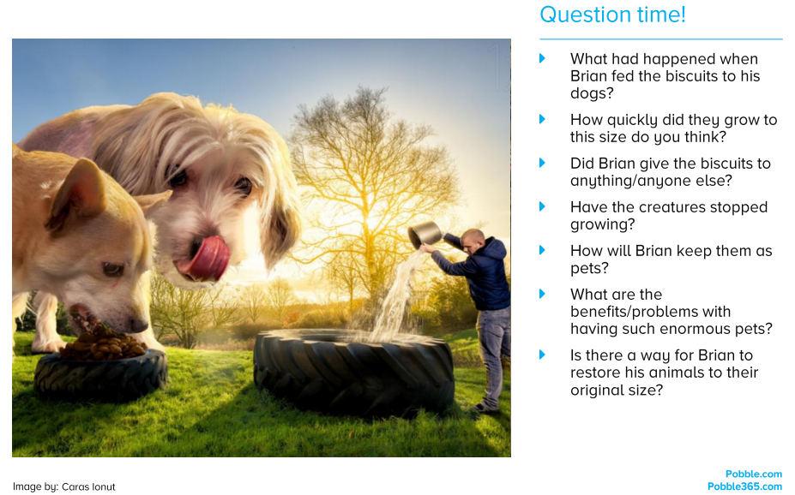
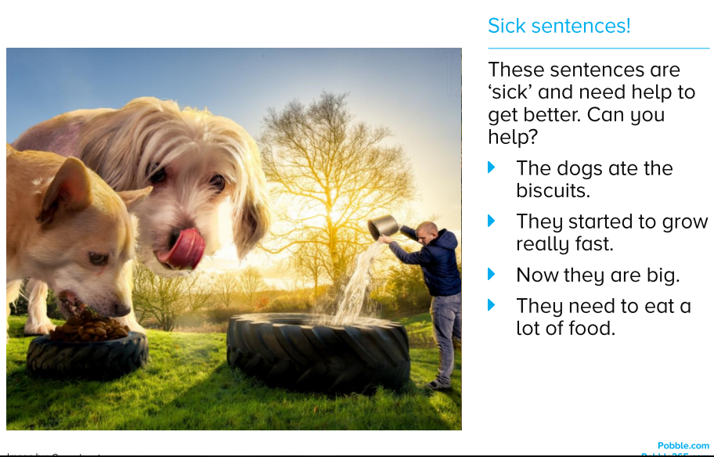
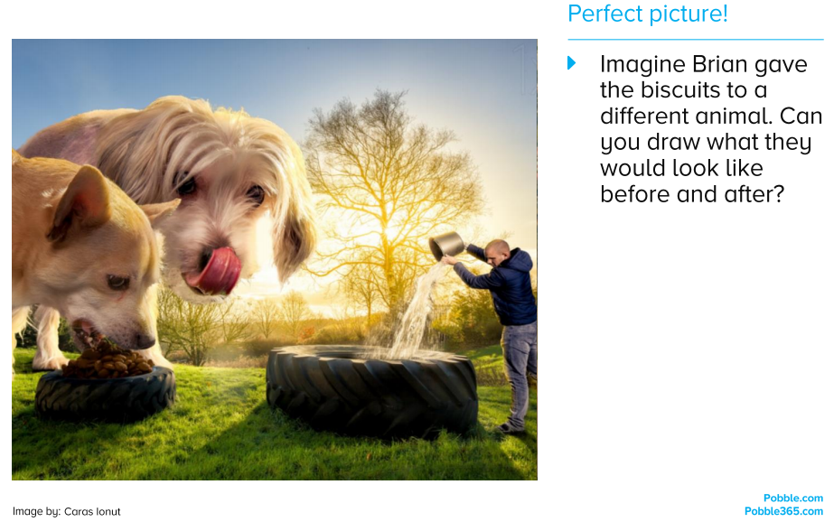
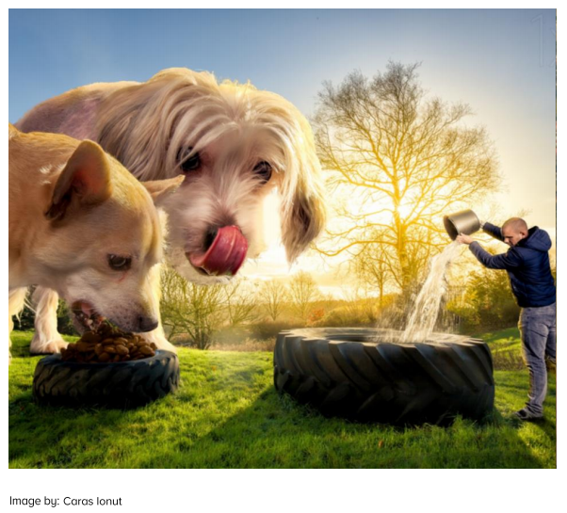
Can you create an information leaflet to tell someone how to look after a dog?
You will need to think about…
- Diet
- Exercise
- Grooming
- Playing
- Keeping your dog healthy – vaccinations, vet visits, teeth cleaning…
- Equipment you will need – lead, food / water bowls, toys, dog bed

