Literacy session 3
The Strange Ship
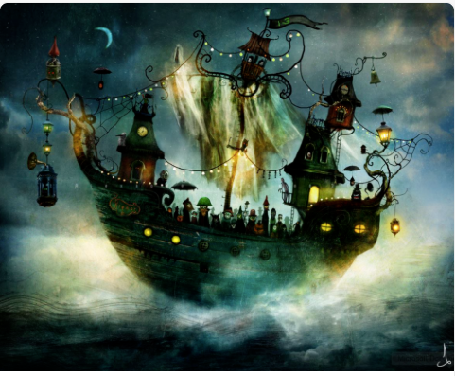

Time to talk…
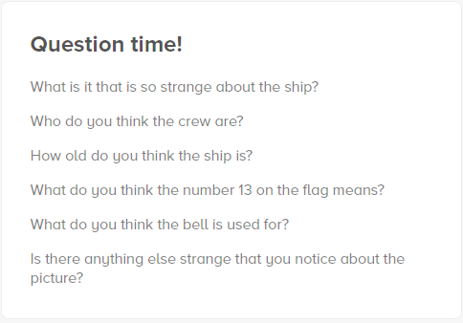
Time to write…
Challenge:
This book has lost its blurb. Can you write an exciting blurb that makes people really want to keep on reading?

Time to draw…

