Literacy session 2
The House in the Rainforest

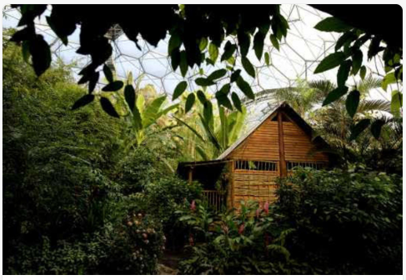

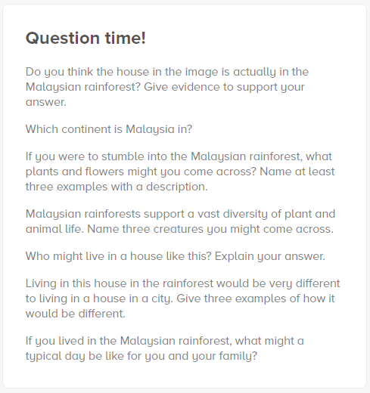
Time to talk…

Time to create a picture…
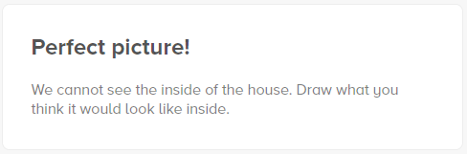

Time to write a story…
(You may find it easier to draw a story map when planning your story)
Don’t forget to include:
- Capital letters and full stops
- Expanded noun phrases
- Time adverbs – first, next, after that, then, finally
Re-read your story to check your spelling and punctuation. Can you add any extra detail? Do you need to take anything out?

