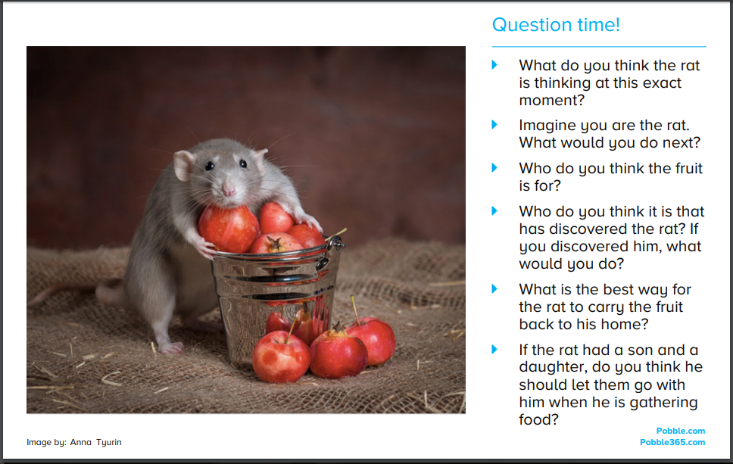
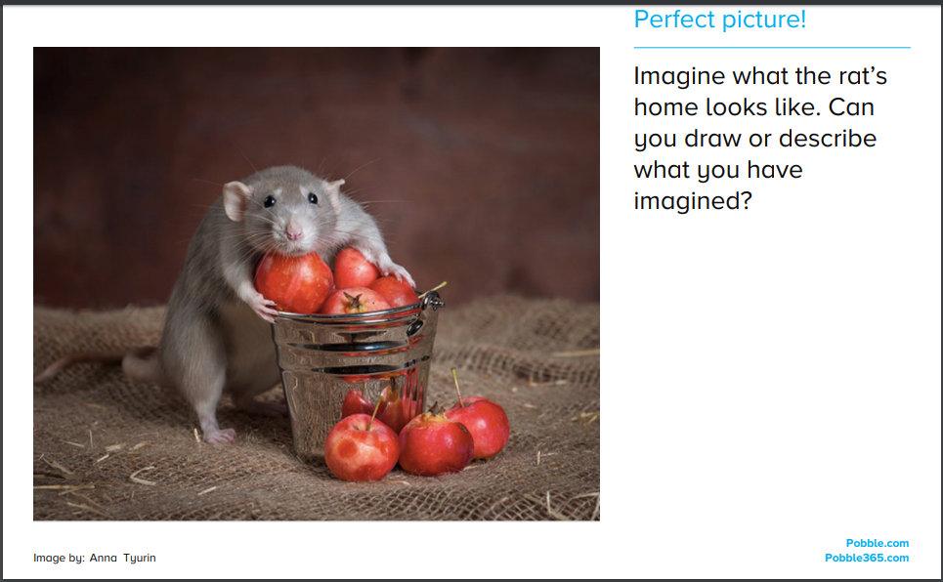

Challenge

- Here is the start of a story about the rat.
- Can you complete the story?
- It may help you to draw a story map to plan the next parts of the story.
- Remember a good story has a clear beginning, middle and ending.
- Things to include…
- Expanded noun phrases – the small, brown rat
- Adverbs – adding ly endings – quickly / swiftly / cautiously
- Subordination – use because / so that to provide explanations

