Written Task 1 – This is a History Detective task and should be completed BEFORE reading any further.
What questions can you ask about this photo? Try to think of between 5 and 10 questions. Children in Foundation and Year 1 might ask an adult to scribe their questions.

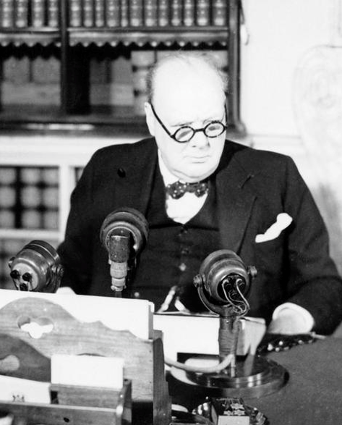

Written Task 2 – This is a History Detective task and should be completed BEFORE reading any further.
What questions can you ask about this photo? Try to think of between 5 and 10 questions. Children in Foundation and Year 1 might ask an adult to scribe their questions.
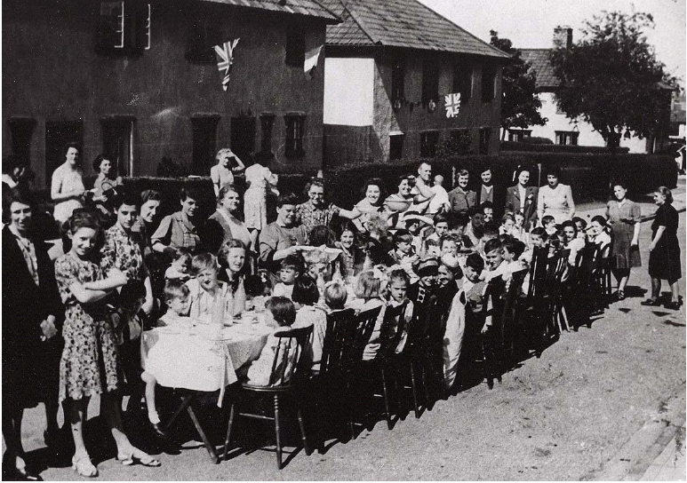

Task 3 (Research / discussion) – The first photo shows the Prime Minister Winston Churchill announcing VE Day - Victory in Europe. This day marks the end of the Second World War in Europe. There were no mobile phones or internet in those days. How would he have given this news?
Task 4 (Research / discussion) - The second photo shows people celebrating VE Day on May 8th 1945. Can you find out what VE day was and some of the ways in which it was celebrated?

Task 5
Foundation Stage Children Final Written task
If you could have a street party with all your neighbours…What games would you play, what food you would eat, what would you wear? Use any medium to draw or write about your street party. Perhaps you could make something at home that you would like to have to eat at your street party. You might want to find out what people ate at the street parties on VE day.

KS1 Final Written task
Street parties were not the only way in which many people celebrated the end of the war. Can you draw and write about how else they might have celebrated? If you can, use photos from this website https://www.iwm.org.uk/history/10-photos-of-ve-day-celebrations

Useful websites
https://www.britishpathe.com/video/ve-day-celebrations
https://www.bbc.co.uk/teach/class-clips-video/history-ks2-ve-day/z7xtmfr
https://www.iwm.org.uk/history/what-you-need-to-know-about-ve-day
https://www.iwm.org.uk/history/10-photos-of-ve-day-celebrations
https://www.bbc.co.uk/newsround/48201749
https://www.iwm.org.uk/history/what-you-need-to-know-about-rationing-in-the-second-world-war

