Over Easter and into the Summer term, please have a look at the White Rose Home Learning website:
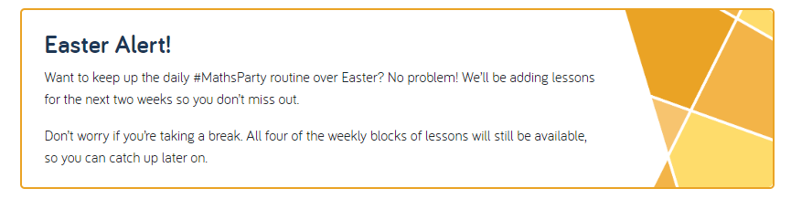
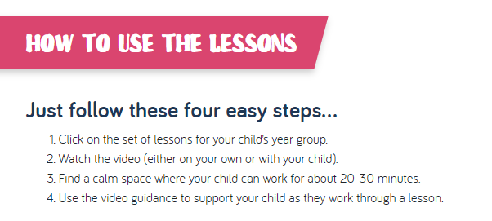
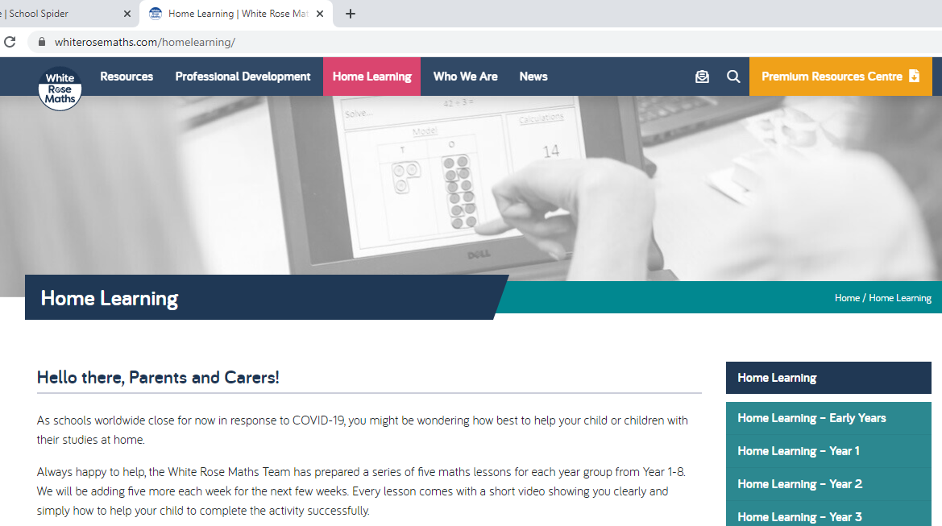
https://whiterosemaths.com/homelearning/

